**Power Substitute for Special Area Coverage**

1. Go to the Prospect website. Hempsteadschools.org/schools/prospect
2. 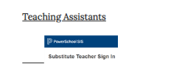Go to teacher/staff tab
3. Scroll down and click on Power Substitute
4. Select

Language: English

School: Prospect Elementary School

Teacher: (special area teacher you are covering for)

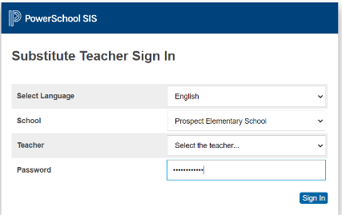Password: Prospect2223

1. 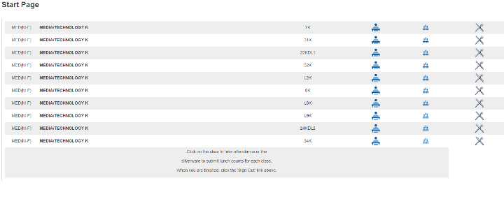Find the room number of the class you are covering.

Click the student next to the room number.

**Each student needs a mark. After each student is given a mark press submit at the bottom.**

**Present in**- student is present and in school

**Present out**- student is present and at home (remote or quarantined- check list from office)